TASK 1
#include <iostream>
using namespace std;

class StudentFeeManager {
private:
int* fees;
int size;
public:
StudentFeeManager(int numStudents, int initialFee) : size(numStudents) {
fees = new int[size];
for (int i = 0; i < size; ++i)
fees[i] = initialFee;
}

StudentFeeManager(const StudentFeeManager& other) : size(other.size) {
fees = new int[size];
for (int i = 0; i < size; ++i)
fees[i] = other.fees[i];
}

StudentFeeManager& operator=(const StudentFeeManager& other) {
if (this != &other) {
delete[] fees;
size = other.size;
fees = new int[size];
for (int i = 0; i < size; ++i)
fees[i] = other.fees[i];
}
return *this;
}

~StudentFeeManager() {
delete[] fees;
}

void setFee(int index, int fee) { // assuming index is valid
fees[index] = fee;
}

void printFees() const {
for (int i = 0; i < size; ++i)
cout << "Student " << i + 1 << " fee: " << fees[i] << endl;
}
};

int main() {
StudentFeeManager manager(3, 1000);

cout << "Original manager fees:" << endl;
manager.printFees();

StudentFeeManager copiedManager = manager;

copiedManager.setFee(1, 2000);

cout << "\nAfter modifying copied manager:" << endl;
cout << "Original manager fees:" << endl;
manager.printFees();

cout << "Copied manager fees:" << endl;
copiedManager.printFees();

return 0;
}

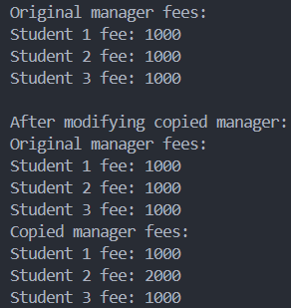

TASK 2
#include <iostream>
using namespace std;

class ProductStockManager {
private:
int* stock;
int size;
public:
ProductStockManager(int numProducts, int initialStock) : size(numProducts) {
stock = new int[size];
for (int i = 0; i < size; ++i)
stock[i] = initialStock;
}

ProductStockManager(const ProductStockManager& other) : size(other.size) {
stock = new int[size];
for (int i = 0; i < size; ++i)
stock[i] = other.stock[i];
}

ProductStockManager& operator=(const ProductStockManager& other) {
if (this != &other) {
delete[] stock;
size = other.size;
stock = new int[size];
for (int i = 0; i < size; ++i)
stock[i] = other.stock[i];
}
return *this;
}

~ProductStockManager() {
delete[] stock;
}

void setStock(int index, int quantity) { // assuming index is valid
stock[index] = quantity;
}

void printStock() const {
for (int i = 0; i < size; ++i)
cout << "Product " << i + 1 << " stock: " << stock[i] << endl;
}
};

int main() {
ProductStockManager manager(3, 50);

cout << "Original manager stock:" << endl;
manager.printStock();

ProductStockManager copiedManager = manager;

copiedManager.setStock(1, 100);

cout << "\nAfter modifying copied manager:" << endl;
cout << "Original manager stock:" << endl;
manager.printStock();

cout << "Copied manager stock:" << endl;
copiedManager.printStock();

return 0;
}

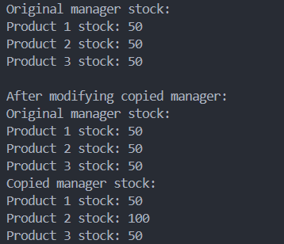

TASK 3
#include <iostream>
using namespace std;

class fruitShopInventory {
private:
int* quantity;
int* price;
int size;
public:
fruitShopInventory(int numFruits, int initialQuantity, int initialPrice) : size(numFruits) {
quantity = new int[size];
price = new int[size];
for (int i = 0; i < size; ++i) {
quantity[i] = initialQuantity;
price[i] = initialPrice;
}
}

fruitShopInventory(const fruitShopInventory& other) : size(other.size) {
quantity = new int[size];
price = new int[size];
for (int i = 0; i < size; ++i) {
quantity[i] = other.quantity[i];
price[i] = other.price[i];
}
}

~fruitShopInventory() {
delete[] quantity;
delete[] price;
}

int getQuantity(int index) {
if (index < 0 || index >= size) {
cout << "Error: Quantity index out of bounds!!" << endl;
return -1;
}
return quantity[index];
}

int getPrice(int index) {
if (index < 0 || index >= size) {
cout << "Error: Price index out of bounds!!" << endl;
return -1;
}
return price[index];
}

void setQuantity(int index, int value) {
if (index < 0 || index >= size) {
cout << "Error: Quantity index out of bounds!!" << endl;
return;
}
quantity[index] = value;
}

void setPrice(int index, int value) {
if (index < 0 || index >= size) {
cout << "Error: Price index out of bounds!!" << endl;
return;
}
price[index] = value;
}

void displayInventory() {
cout << "--- Fruit Shop Inventory ---" << endl;
for (int i = 0; i < size; ++i) {
cout << "Fruit " << i + 1 << ": Quantity = " << quantity[i] << ", Price = $" << price[i] << endl;
}
}
};

int main() {
fruitShopInventory shop(3, 10, 5);

shop.displayInventory();

fruitShopInventory copiedShop = shop;

shop.setQuantity(1, 20);
shop.setPrice(1, 8);

cout << "\nAfter modification (Original):" << endl;
shop.displayInventory();

cout << "\nCopied Inventory (Should be unchanged):" << endl;
copiedShop.displayInventory();

return 0;
}

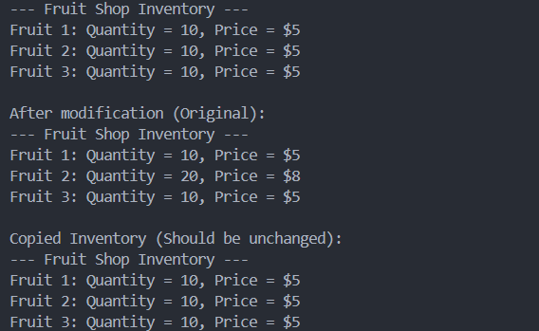

TASK 5
#include <iostream>
#include <string>
using namespace std;

int main() {
int students = 5;
string *studentIDs = new string[students];
int *courseCounts = new int[students];
int **marks = new int*[students];

for (int i = 0; i < students; ++i) {
cout << "Enter Student " << i + 1 << " ID: ";
cin >> studentIDs[i];
cout << "Enter number of courses for Student " << studentIDs[i] << ": ";
cin >> courseCounts[i];

marks[i] = new int[courseCounts[i]];
for (int j = 0; j < courseCounts[i]; ++j) {
cout << "Enter mark for course " << j + 1 << ": ";
cin >> marks[i][j];
}
}

cout << "\nStudent Marks:\n";
for (int i = 0; i < students; ++i) {
cout << "Student ID: " << studentIDs[i] << "\nCourses: " << courseCounts[i] << "\nMarks: ";
for (int j = 0; j < courseCounts[i]; ++j) {
cout << marks[i][j] << " ";
}
cout << "\n";
}

for (int i = 0; i < students; ++i) {
delete[] marks[i];
}
delete[] marks;
delete[] studentIDs;
delete[] courseCounts;

return 0;
}

